**Euclid Property**

* **Single story with basement**
* **Three bedrooms two full bathrooms**
* **RV parking on the side**
* **Additional parking in back with alley access**

Overview – remodeled the entire home

**Demolition – removed the following:**

* Chain link fencing around the entire property
* Shed on back patio
* Trees surrounding the property in poor health
* Dark wood paneling in the basement living room and bonus room

**Finishing touches – Added the following:**

* Poured an additional concrete slab in the front for additional parking in the front
* Front & back doors
* Kitchen area
  + Relocated fridge - moved from next to stove to right next to dishwasher
  + Added counter space near range
* Fencing around the entire property
* Relocated mail box from the house to the front of the property
* Relocated overhead ductwork in basement to create height
  + Laundry room
  + Living room
* Removed pipe in stairway which was used as a railing
* Created master bedroom in basement
  + Converted basement bonus area into master bedroom
  + Made pantry into walk-in closet
* All new windows throughout the home
  + Added kitchen window overseeing the backyard & creating additional natural lighting
* All new bathroom fixtures
  + Tub
  + Showers
  + Faucets
  + Shower heads
* All new flooring throughout property
  + Upstairs – laminate, carpet & tile
  + Basement - carpet & tile
* New paint interior & exterior
  + Scraped, caulked, primed & painted exterior

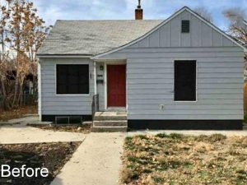 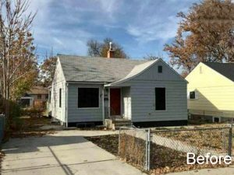

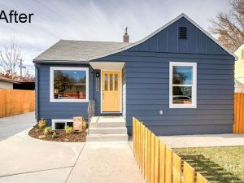 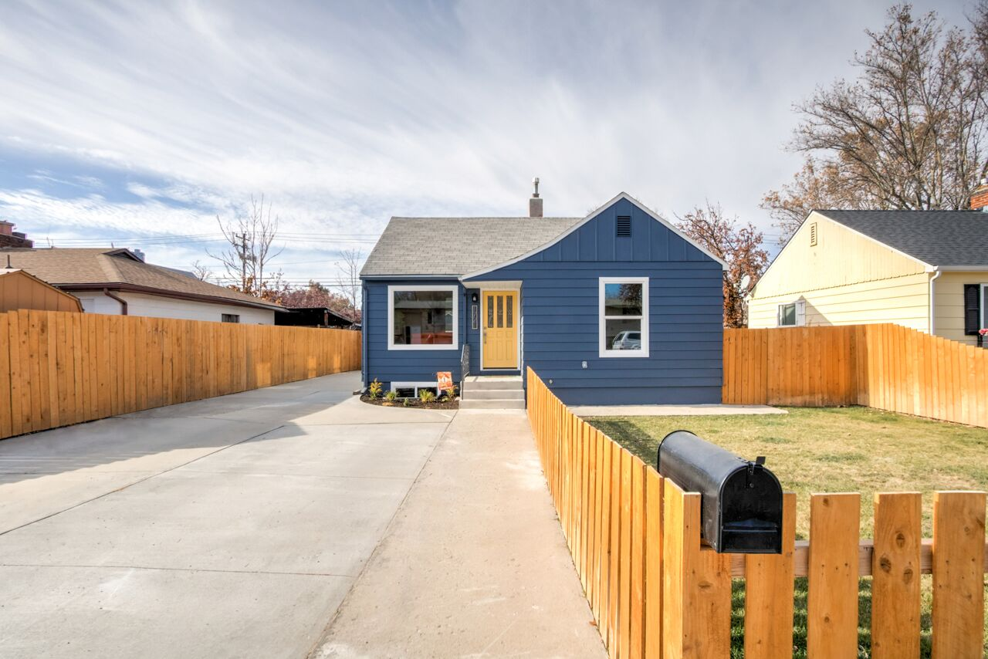

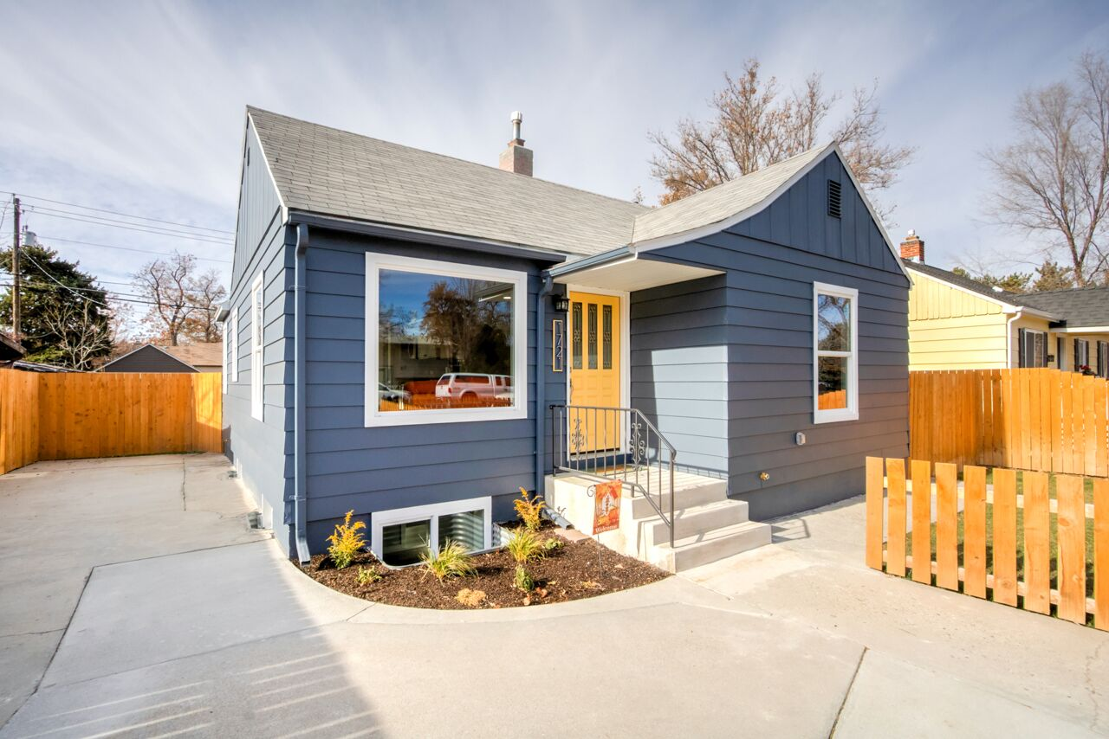

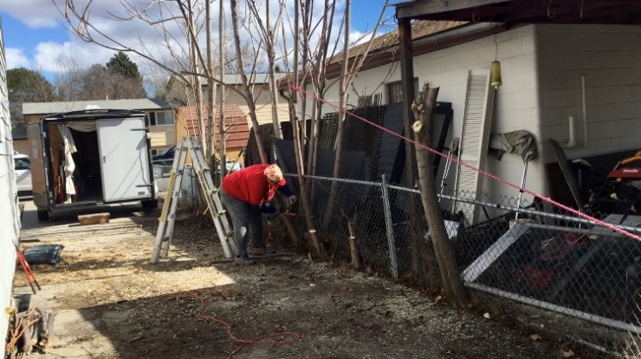 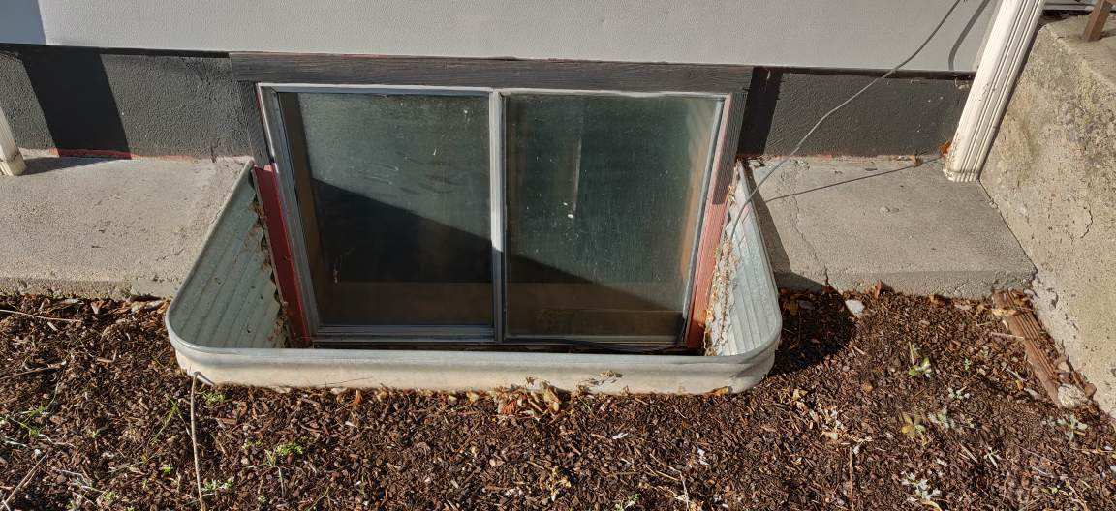

View of neighbor’s (to the left) before new cedar fence was installed & trees were cut down & front window well

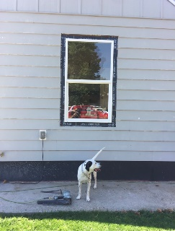 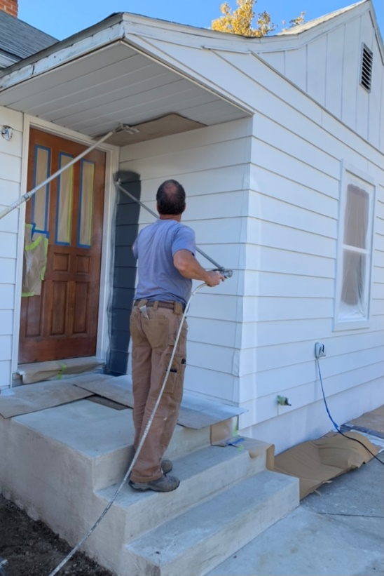

Front of home getting painted with two coats after being primed

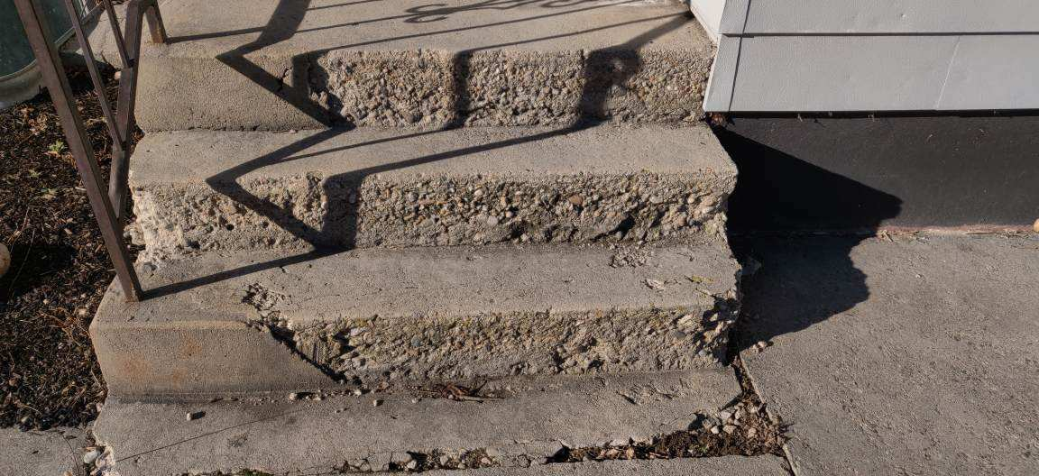 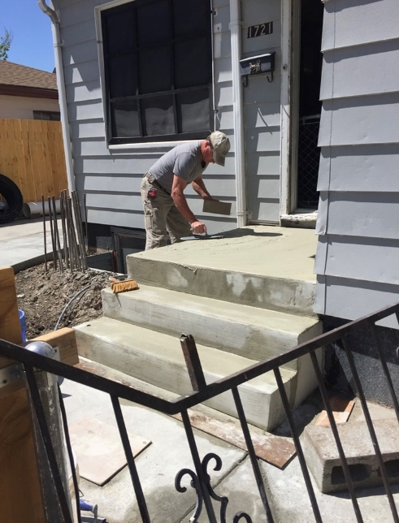

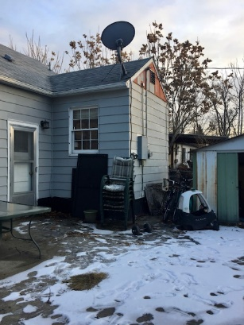 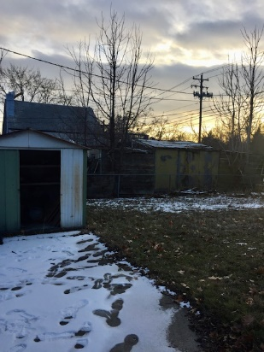 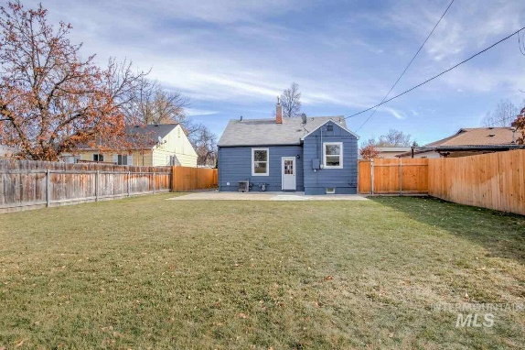

Removed shed & trees to clean up property and creating a blank slate for the new owners

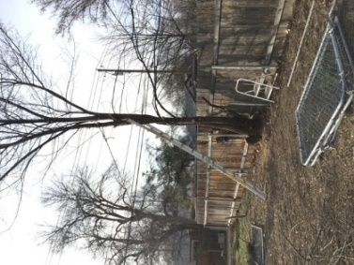 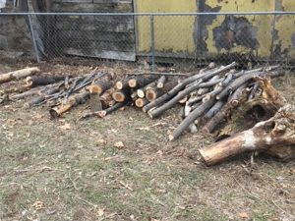 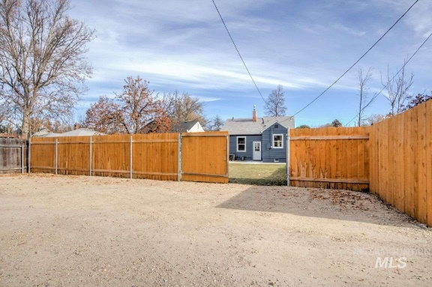

Removed trees & all the grass, hydroseeded and created parking in the rear alley way

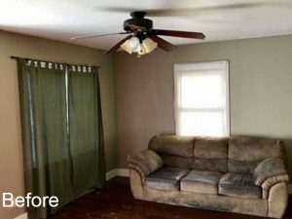 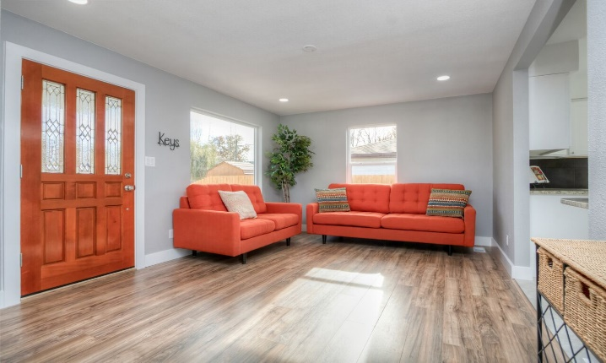

Replaced flooring to brighten the living room area

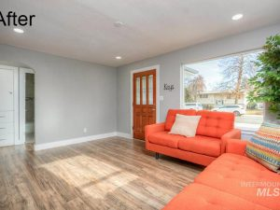 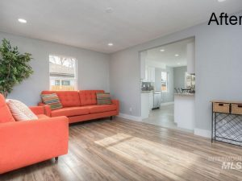

Enlarged entry to kitchen from living room area

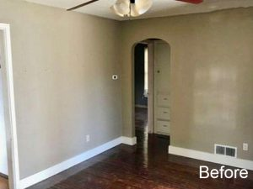 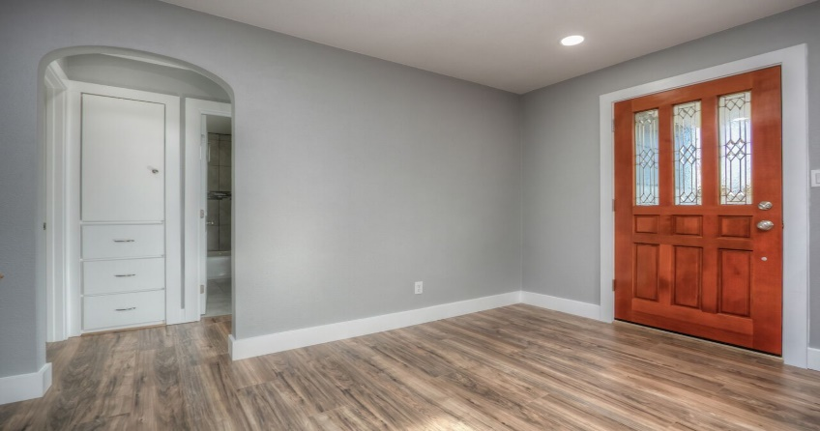

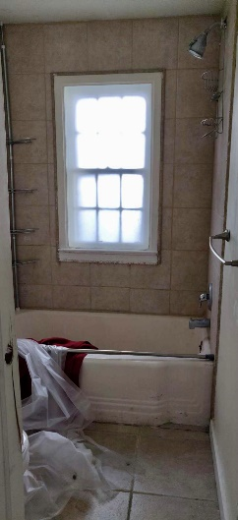 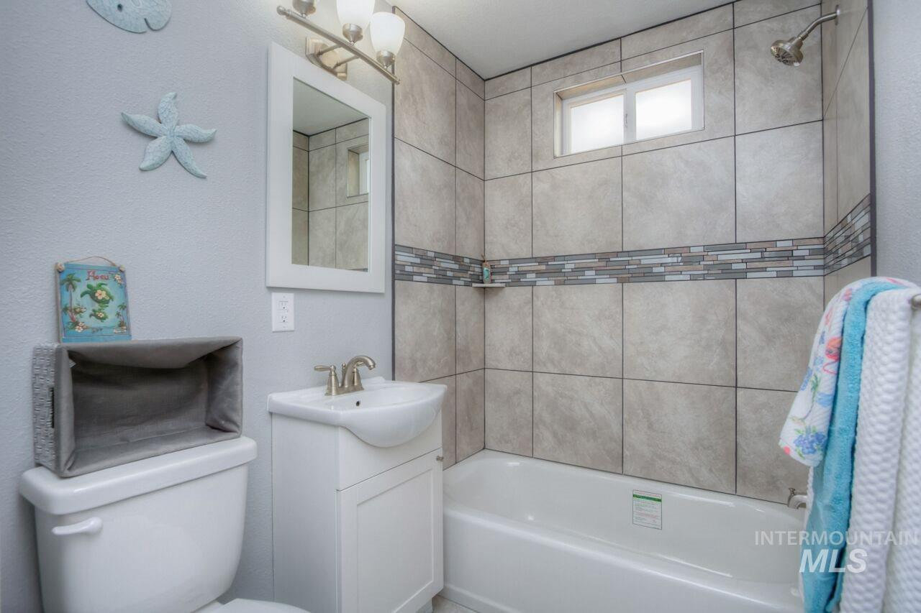

Upstairs hall bathroom

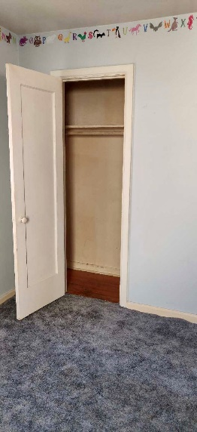 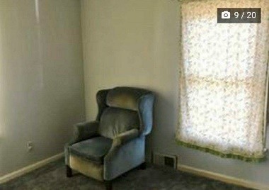 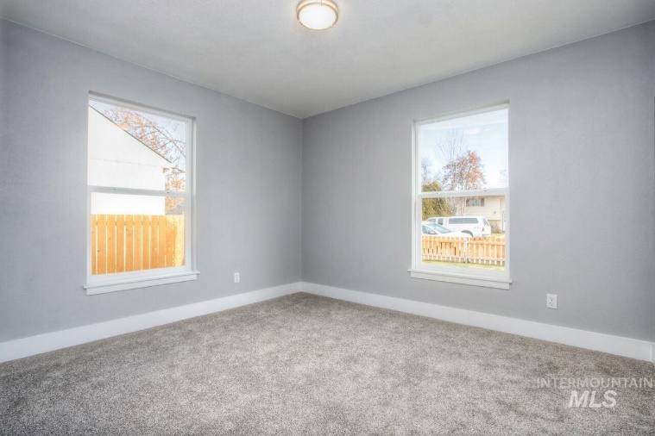

Upstairs – front bedroom

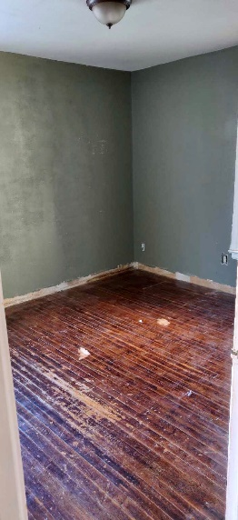 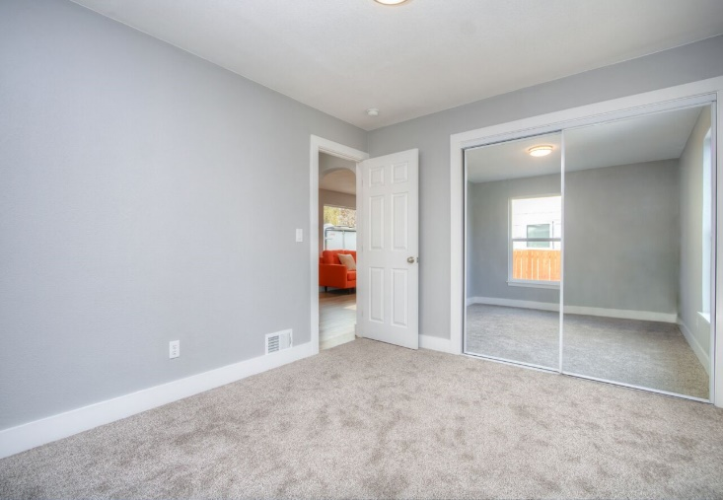

Upstairs – Back bedroom – we added mirrored closet doors to make the room appear bigger & brighter

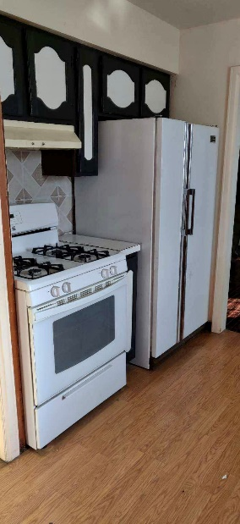 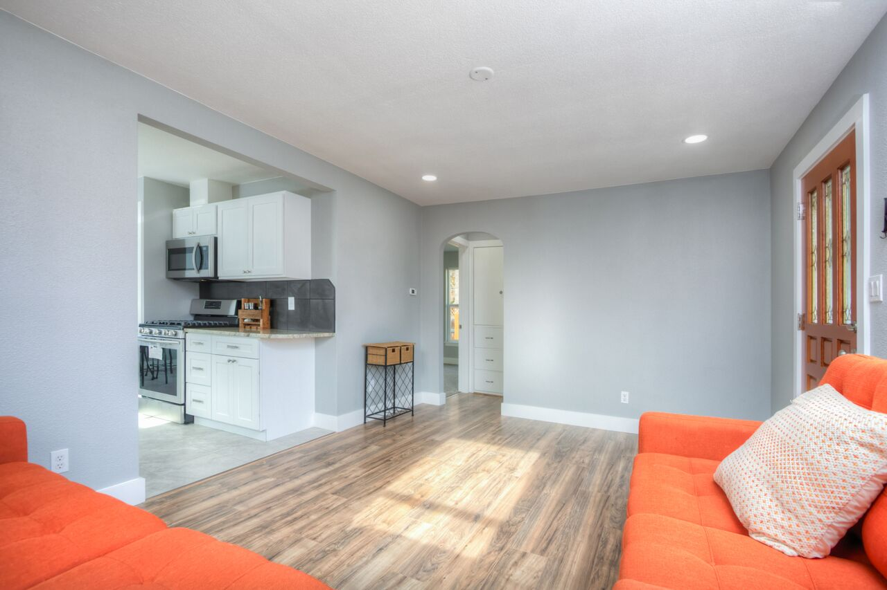

Enlarged entry to kitchen by relocating fridge

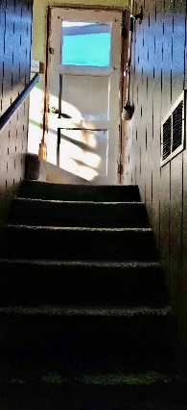 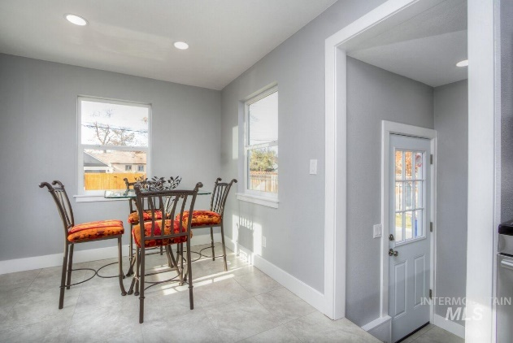

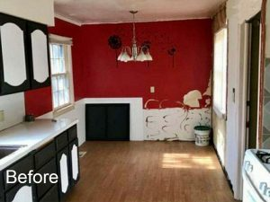 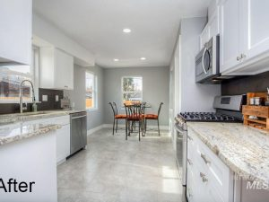

Added a window in the dining room creating backyard view

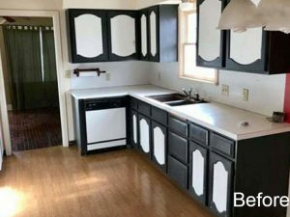 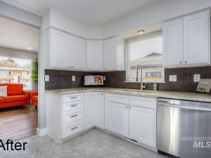

Changed all the cabinets for a cleaner look

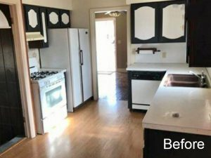 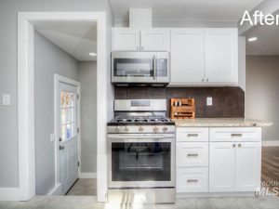

Relocated fridge area next to dishwasher creating more space next to the range

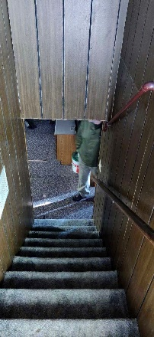 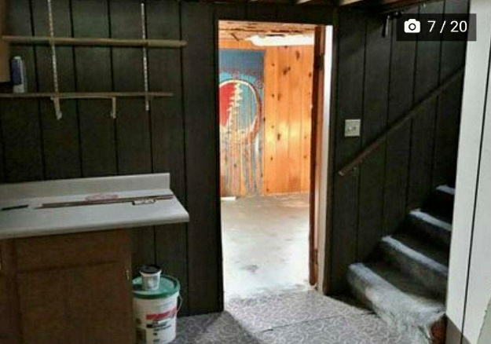 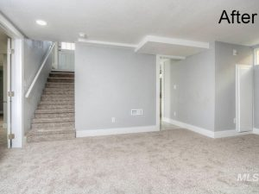

Took down all the wood paneling on the walls & raised the ducts in the basement for more height

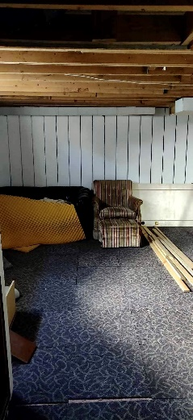 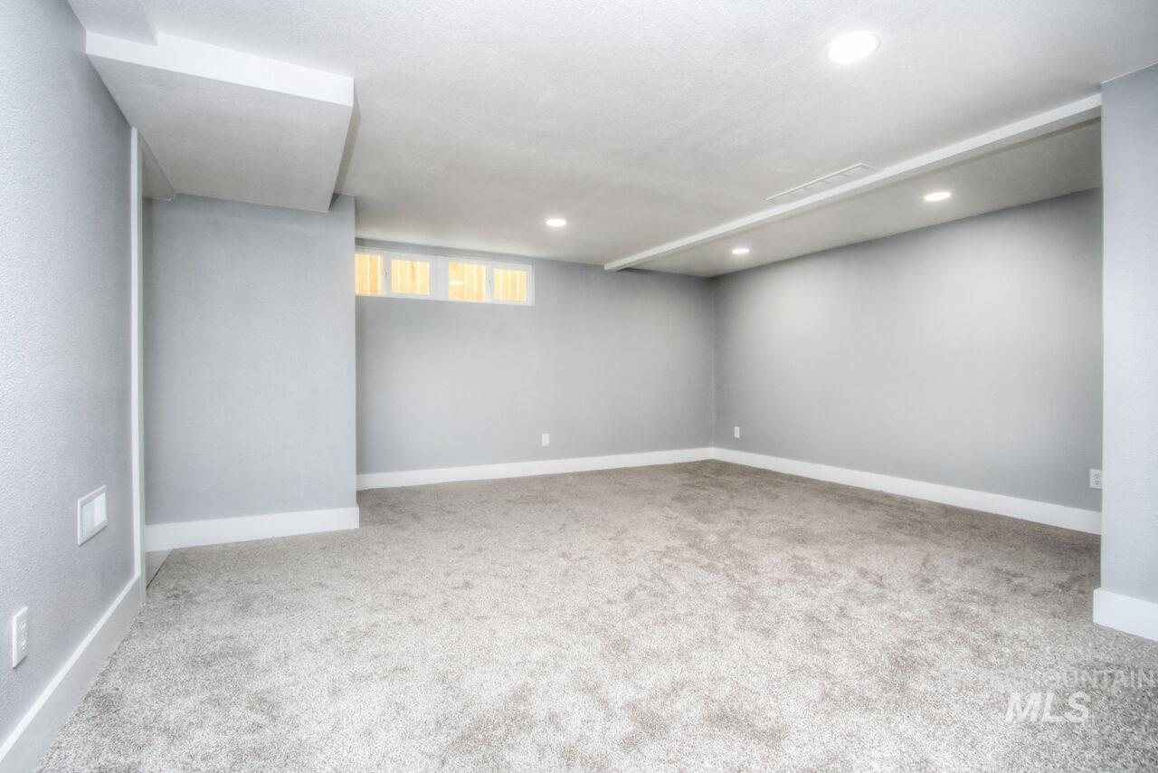

Basement was dark & dungeon looking so we created a light & airy space

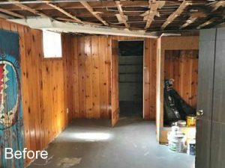 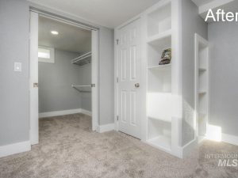

Created a master bedroom with walk-in closet in the basement

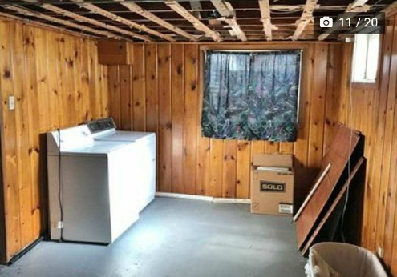 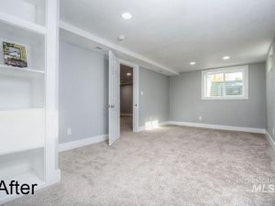

Basement master was dark

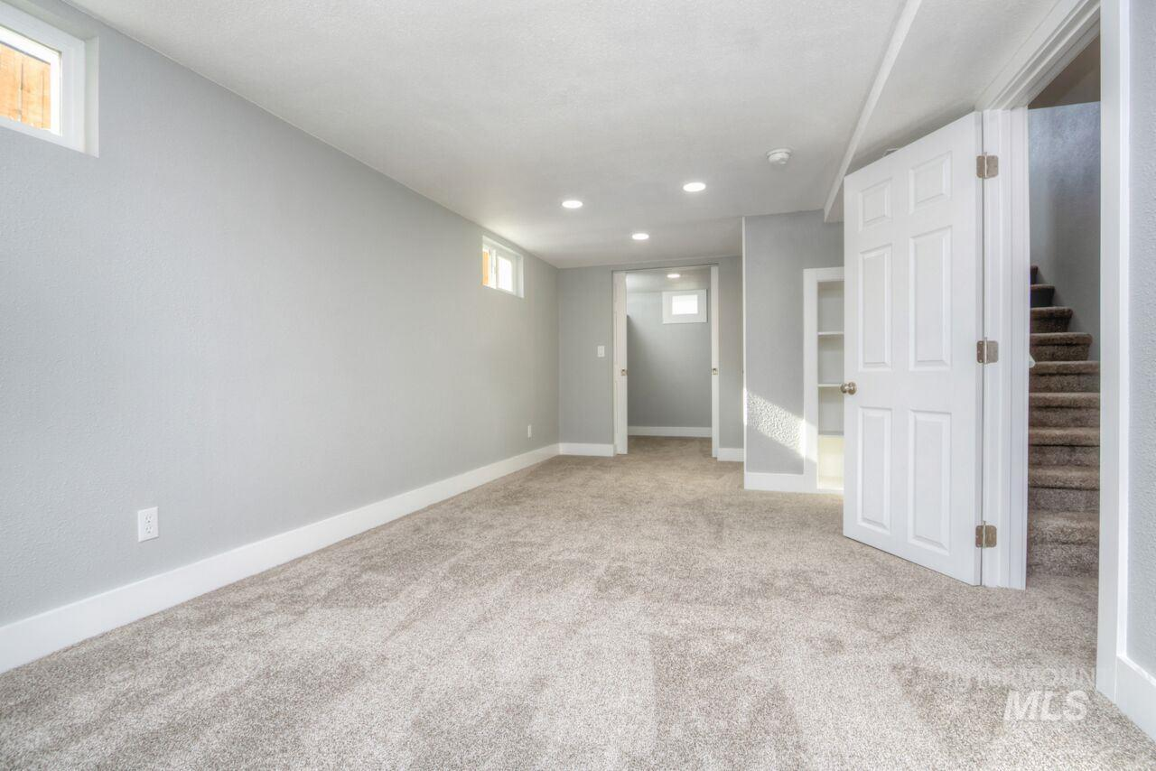

View of master bedroom in basement with walk-in closet

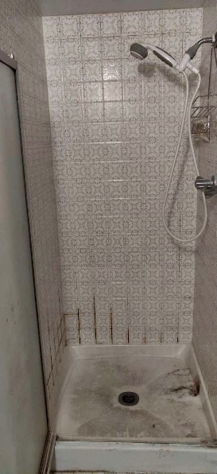 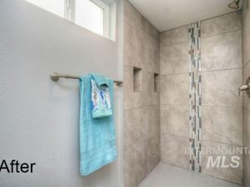

Basement bathroom

